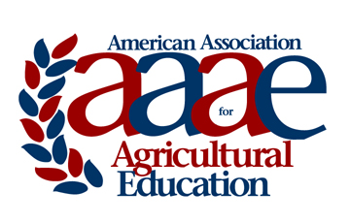 | NC-AAAE OUTSTANDING AGRICULTURAL EDUCATOR AWARD  Award Criteria & Nomination Instructions

The American Association for Agricultural Education recognizes annually an individual who has made outstanding contributions over the years to agricultural education. Following is a description of the award, the selection procedures, and criteria for the selection of recipients.

Purpose and Selection Procedures

1. The purpose of the award is to recognize and encourage superior contribution in agricultural education.
2. Nominations may be made by an active member of the association and those outside AAAE.
3. Nominees must be active members who have maintained reasonably continuous membership in the association.
4. Electronic copy of completed nominations are due by the designated deadline date to the AAAE chair list on the form.
5. Nominations shall be limited to three typewritten pages. No other supporting information (letters, etc.) will be accepted.
6. Nominee must not have received this award previously.

Criteria for Selection of Recipients

The basis of the award will be: 1) excellence in teaching undergraduates, graduate students or both; 2) significant research in the field of agricultural education and related areas; 3) scholarly writing pertaining to education; and 4) service to agricultural education and related areas.

Evidence relating to excellence in some or all of the following shall accompany each nomination.

1. Excellence in teaching -- preservice and in-service -- undergraduate, graduate, or non-credit courses or programs. Knowledge of field, methodology, and achievement.
2. Research -- personally completed or directed. (Bibliography)
3. Writings -- books, periodicals, bulletins and editorial services.
4. Service rendered -- professional, to community, to state and to the nation. (List)

Longevity will be considered, but will not necessarily be a prime factor in the selection of recipients. The award is intended to serve as an incentive for accomplishment on the part of recipients with many future years of service as well as to recognize accomplishments of those nearing retirement.

NC-AAAE OUTSTANDING AGRICULTURAL EDUCATOR AWARD

NOMINATION FORM

Name of Nominee:
Institution:
Professional Employment Record:

Degrees Held:

Nomination Submitted by:
Contact information for nominator:

Nomination Packet including all supporting materials should be saved as a pdf file and electronically submitted via email no later than September 1 to:

Adam Marx, Ph.D.
Assistant Professor
Agricultural Education
North Dakota State University

Email: adam.marx@ndsu.edu

Direct: (701) 231-7439
Cell: (937) 726-1814
NOMINATIONS SHALL BE LIMITED TO THREE TYPEWRITTEN PAGES
PAGES OVER 3 WILL BE REMOVED

