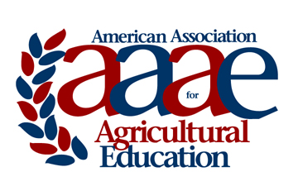 | NC-AAAE OUTSTANDING EARLY CAREER MEMBER  Award Criteria & Nomination Instructions

The American Association for Agricultural Education will recognize, on an annual basis, an outstanding young member who has made significant contributions to agricultural education broadly defined. Following is a description of the award, selection procedures, and criteria for selection of recipients.

- Nominator may be from outside the AAAE organization.
- Nominee must be an active NC AAAE member who has maintained reasonably continuous membership in the association.
- Nominee must have completed no more than seven (7) years of professional experience in a position that conveys eligibility for active AAAE membership as of the date the award is conferred.
3. Nominations shall be limited to a cover page and three typewritten pages of supporting documentation. No other supporting information (letters, etc.) will be accepted.
4. Nominee must not have received this award previously.

Criteria for selection
The basis of the award will be: 1) excellence in teaching undergraduates, graduate students or both; 2) significant research in the field of agricultural education and related areas; 3) scholarly writing pertaining to agricultural education and related areas; and 4) service to agricultural education and related areas.

Evidence relating to the following shall accompany each nomination.

1. Excellence in teaching --undergraduate, graduate, or non-credit courses or programs. Knowledge of the field, methodology, and achievement.
2. Research -- personally completed or directed. (Bibliography)
3. Writings -- books, periodicals, bulletins, and editorial services.
4. Service rendered -- professional, to community, to state, and to the nation. (List)

NC-AAAE OUTSTANDING EARLY CAREER MEMBER

COVER SHEET
Name of Nominee:
Institution:
Title:
Professional Employment Record:

Degrees Held:

Nomination Submitted by:
Contact information for nominator:

Nomination packet, including all supporting material, should be saved as a single pdf file and electronically submitted via email no later than 11:59 p.m. CDT on Wednesday, September 12 to:

Tim Buttles, University of Wisconsin – River Falls Ag Education Department

Email: timothy.j.buttles@uwrf.edu Phone: 715-425-4085

THE NOMINATION SHALL BE LIMITED TO THREE TYPEWRITTEN PAGES
ALL PAGES OVER 3 WILL BE REMOVED

