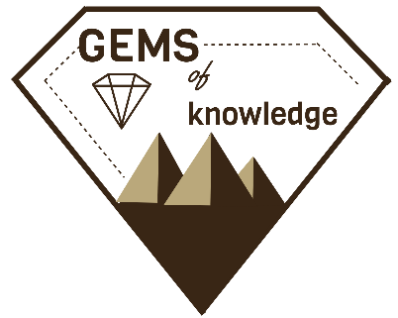
Western Region AAAE Research Conference
“Gems of Knowledge in the Gem State”
September 17-19, 2018
Boise, Idaho
The Grove Hotel
245 S Capitol Blvd., Boise, ID 83702

We are excited for the opportunity to host the Western Region AAAE Research Conference this fall. As you begin to make your travel and scheduling plans, the following information should provide some insight about the conference. We look forward to a great event. – University of Idaho Faculty

Tentative Schedule
Monday, September 17, 2018
7am-12pm | Pre-Conference Meetings | The Grove Hotel
1pm-5pm | Idaho Meat, Potatoes, and More Tours | Treasure Valley Area
5:30pm-7:30pm | Taste of Idaho Night | The Grove Hotel
Tuesday, September 18, 2018
7:30am-6pm | Conference Sessions | The Grove Hotel
Wednesday, September 19, 2018
7:30am-12:00pm | Conference Sessions and Awards Luncheon | The Grove Hotel
Transportation
- Flights are available into the Boise Airport (BOI) on the following airlines: Alaska, Allegiant, American, Delta, Frontier, Southwest, and United
- The Grove Hotel offers a complimentary airport shuttle
- Conference events will take place in downtown Boise, which was recently ranked a top 10 pedestrian city
- Onsite parking is available with both self-park ($15/day) and valet ($22/day) options. No large vehicles are permitted (6’8” maximum height)
Lodging- The Grove Hotel
- Room rates are negotiated in the AAAE block at $154/night for single and double rooms. Please request the American Association for Agricultural Education room block to secure rates.
- The hotel block guarantees rates from Sunday, September 16th through Thursday, September 19th
- To guarantee rates within the block, please reserve your rooms before August 27th, 2018.
Other Adventures
- Potential pre and post-conference excursions are being discussed including: Rafting/Kayaking, Hiking, and Fishing
- If you are interested in joining in on an excursion for either Sunday or after the conference, please let us know!
For more information contact Kasee Smith (klsmith@uidaho.edu) or Kattlyn Wolf (kwolf@uidaho.edu)

