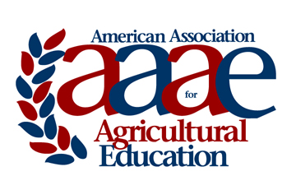 | AAAE HONORARY MEMBERSHIP  NOMINATION FORM & GUIDELINES  2018

Suggested Guidelines:
1. Honorary membership may be conferred upon recommendation of the Board of Directors to persons who have distinguished themselves by their outstanding contributions to the objectives of the Association (statement from AAAE Constitution).

2. Recipients of the award should be limited to individuals outside the membership of AAAE.

3. Recipients should have a record of service characterized by being:

a. Specifically contributory to education in agriculture.

b. National in scope.

c. Extended over a period of time longer than one event or one year. (This criterion differentiates the Honorary Membership Award from the Special Awards.)

AAAE Honorary Membership

Nomination Form

Name of Nominee:
Position:
Address:

Information supporting nominee for Honorary Membership:

Nomination Submitted by:
Nomination should be saved as a pdf file and electronically submitted via email no later than March 2nd.

For questions and submission, contact:
Dr. Rob Terry
Oklahoma State University
Phone: 405-744-8140
Email: rob.terry@okstate.edu

