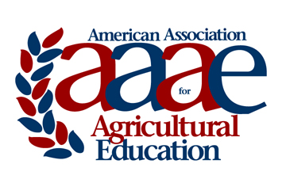 | AAAE Life Membership  Award Criteria & Nomination Instructions

The purpose of the American Association for Agricultural Education (AAAE) Life Membership is to recognize retiring AAAE members in recognition of long-term dedication toward the achievement of the AAAE mission and goals.

Eligible AAAE members are those who have retired since the last annual conference or will be retiring during the upcoming year, before the next annual conference; and have paid their AAAE dues for the three years prior to retirement.

To receive Life Membership status an individual must be nominated by fellow AAAE members and approved by the AAAE Board of Directors

Identify below AAAE Members who quality for AAAE Life Membership.

Name | University/College | Date of Retirement

Nominated by ________________________________________

Nomination should be saved as a pdf file and electronically submitted, via email, no later than March 1st to:
Mark Balschweid
Department of Agricultural Leadership, Education, and Communication
University of Nebraska
Email: mbalschweid2@unl.edu
Phone: (402) 472-8738

