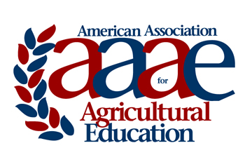 | AAAE Memorial Brief
Name of Deceased:
Institution:
State:
Brief Memorial Statement:

Memorials should be saved as a pdf file and electronically submitted via email no later than March 1st to:

Mark Balschweid
Department of Agricultural Leadership, Education, and Communication
University of Nebraska
Email: mbalschweid2@unl.edu
Phone: (402) 472-8738

