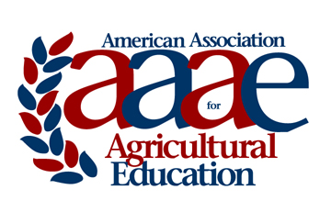 | Outstanding Thesis Award  Award Criteria & Nomination Instruction  *Updated on 7/22/16 to reflect changes approved at the 2016 AAAE Conference

Introduction:

The American Association for Agricultural Education has established a master’s thesis award program. The program is designed to recognize the master’s student who has completed the most outstanding thesis during the previous calendar year. Each master’s degree granting institution awarding a M.S. from a department of Agricultural or Extension Education (or similar) is eligible to submit one outstanding thesis.

Eligibility:

Master’s students completing a thesis with a defense date between January 1st and December 31st (of the previous year) are eligible for consideration for each year’s award competition.
- Only one nomination will be accepted per institution each year. Each institution is responsible for the procedures by which their nominee is selected.
- Master’s student must be a member (student or active) or their advisor, or nominator must be a member of AAAE in order to be eligible for the award.

Format:

The submission will be the full thesis.

Procedures:

A letter of nomination from the nominee’s advisor (co-signed by the departmental administrator) should be addressed to: AAAE Outstanding Thesis Selection Committee and uploaded with the paper to the award nomination website at http://www.agedweb.org/AAAE/awards/. A member login is required to upload.

Nominations must be received by February 1st to be considered for the award presented at the AAAE annual meeting in May each year.

Judging and Awards:

- Judging and selection of the award recipient will be conducted by a committee of AAAE fellows.
- Faculty advisors of the nominees are ineligible to serve on the selection committee.
- A plaque will be presented to the recipient and a certificate presented to the award recipient’s faculty advisor at the AAAE annual meeting.

Selection Criteria | Point Value
A. Problem Statement | 10
B. Theoretical Framework | 10
C. Research Design/Procedures | 10
D. Data Analysis Technique(s) | 10
E. Findings | 10
F. Conclusions | 20
G. Recommendations/Implications | 20
H. Value to Agricultural Education | 10
Total Points Possible | 100

For questions, please contact the Chair of the AAAE Research Committee:
Marshall Baker
bakerma@okstate.edu

