American Association for Agricultural Education
2016 North Central Conference
October 6-8, Lafayette, IN

Welcome to Lafayette/West Lafayette and Purdue University!
Complete your Conference Registration and Hotel Reservation by September 16

My Purdue colleagues and I look forward to hosting you for the 2016 North Central AAAE Conference. If you have any questions or need assistance with registration or hotel arrangements please do not hesitate to contact us at 765.494.8423. We look forward to seeing you in Lafayette/West Lafayette! ---- Roger Tormoehlen

Conference Hotel
Holiday Inn – City Center
515 South Street
Lafayette, IN 47901

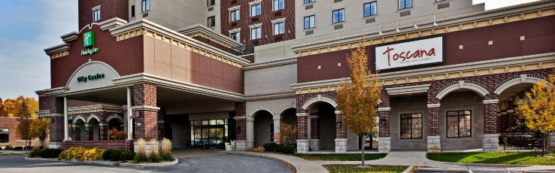
- Cost: $130/room (single or double) plus 12% state & local tax. Tripe and Quad occupancy rooms are available at $140/room and $150/room, respectfully. The room rates are available for one day before and one day after the conference.
Reservations: Call (765) 420-1505 and ask for the North Central AAAE Conference room rate. Alternatively, register online through the following link: North Central AAAE Conference 2016
- The hotel block of rooms is being held until September 16.

Conference
Faculty/Staff $190
Student $150
Guest $50
*** After September 16 a late fee of $25 will be added to all registrations.

- Registration includes Thursday evening Welcome Reception and dinner buffet; Friday breakfast and lunch; and Saturday morning awards breakfast.
- Register at the AAAE Website http://aaaeonline.org/. Select the “Regions” tab and then “North Central Region.”
- Guest registrations include all meal/break functions.

Draft Conference Schedule
Thursday, October 6
3:00 p.m. – 5:00 p.m. Registration
- Grand Ballroom Mezzanine Lobby – Holiday Inn
3:30 p.m. – 4:30 p.m. NC AAAE Executive Meeting
4:30 p.m. – 5:00 p.m. Poster Session I (Innovative Ideas) Set-up
- Lafayette Brewing Company (2 blocks from hotel)
5:00 p.m. – 10:00 p.m. Welcome buffet and Poster Session 1 Innovative Idea (Social time and networking – bar open and games available)
Poster session at 5:00
Dinner buffet and welcome at 6:00
- Lafayette Brewing Company, 2nd floor
Friday, October 7
7:00 a.m. Breakfast
- Grand Ballroom – Holiday Inn
8:00 a.m. – 9:30 a.m. Research Session I
- Spears Room – Holiday Inn
- Shambaugh Room – Holiday Inn
- Pitman Block A – Holiday Inn
9:30 a.m. – 10:00 a.m. Refreshment break
10:00 a.m. – 11:30 a.m. Research Session II
- Spears Room – Holiday Inn
- Shambaugh Room – Holiday Inn
- Pitman Block A – Holiday Inn
11:45 a.m. – 12:45 p.m. Lunch
- Grand Ballroom – Holiday Inn
12:45 p.m. Board buses
1:00 p.m. Buses depart for Purdue University
1:30 – 3:00 Professional Development – Session 1
- Discovery Learning Research Center,
Purdue University
3:00 p.m. – 3:45 pm Poster Session II-Research/Break
- Discovery Learning Research Center,
Purdue University
3:45 p.m. – 4:45 p.m. Professional Development – Session 2
- Discovery Learning Research Center,
Purdue University
4:45 p.m. Board buses
5:00 p.m. Buses depart for Holiday Inn
5:30 p.m. – 7:30 p.m. Dinner on your own
Saturday, October 8
7:00 a.m. – 8:15 a.m. Awards Breakfast
- Pitman Block A&B – Holiday Inn
8:15 a.m. – 9:30 a.m. Committee Meetings
9:30 a.m. – 11:45 a.m. NC AAAE Business Meeting

