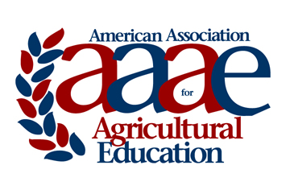 | AAAE DISTINGUISHED RESEARCH AWARD  Award Criteria & Nomination Instructions

Purpose:

To recognize an individual AAAE member for outstanding research accomplishments that have significantly impacted the knowledge base and/or professional practice in Agricultural Education broadly defined.

Nomination and Selection Procedures

- The nomination may be made by a colleague of the nominee. Self-nominations are also accepted.
- Nominations must be submitted by email to the designated award coordinator by the established deadline.
- An AAAE vice president will receive applications and coordinate the selection process.
- The AAAE Board of Directors, upon recommendation of the selection committee, will make the award.

Criteria for Selection

- The nominee must be an active member of the AAAE who has maintained continuous membership in the association.
- Nominees should have sustained a program of research for at least ten years.
- The nominee must have been previously recognized with an AAAE regional research award.
- Selection will be based on documentation of outstanding research accomplishments.
- Candidate’s statement concerning their research focus, research priorities, and actual or anticipated impact on theory and/or practice, not to exceed two typewritten (12 point, Times font) single-spaced pages.
- Evidence of excellent in research should include:
  - Proof of frequent, consistent and important contributions to the knowledge base in Agricultural Education broadly defined as documented by a list of publications and presentations.
  - Recognition through such things as previous research awards, invited presentations, extramural funding, service on grant panels, service as a journal editor, and service on editorial review boards as documented by a list of recognitions.
  - Providing leadership for major research initiatives on a regional, national, or international level as documented by the candidate’s statement and/or a list of contributions.
  - Impact as a research mentor for graduate students, post docs, and early career faculty. This will be documented by two letters of reference from individuals who are familiar with the candidate’s research abilities (such as protégés, professional colleagues, etc.), limited to one single spaced typewritten page for each letter.

Nomination Materials

Nomination packets must include and shall be limited to:

- Cover sheet (see next page).
- Nomination letter (limited to two, single spaced typewritten pages).
- Candidate’s statement (limited to two, single-spaced typewritten pages).
- Evidence of excellence in research (items from #6 above).

AAAE DISTINGUISHED RESEARCH AWARD

COVER SHEET
Name of Nominee:
Institution:
Title:
Professional Employment Record:

Degrees Held:

Nomination Submitted by:
Contact information for nominator:

Nomination packets limited to: Cover sheet, nomination letter, candidate statement, and evidence of excellence in research. Nomination should be saved as one PDF document and electronically submitted using the following link (http://www.agedweb.org/AAAE/awards/) no later than February 17th.

For questions, contact:
Tracy Rutherford
Southern Region VP
trutherford@vt.edu
(540) 231-8187

