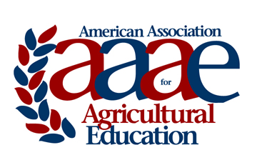 | AAAE SPECIAL AWARD  Award Criteria & Nomination Instructions  2022

Each year the American Association for Agricultural Education (AAAE) Board of Directors solicits nominations for the AAAE Special Award. Below are the criteria, purposes and selection procedures for the awards.

Purpose: The purpose of the AAAE Special Award is to recognize individuals outside the AAAE membership for their support toward the achievement of the mission and goals of the American Association for Agricultural Education.

Selection Procedures: Factors to consider in making the selection include contributions in one or more of the following areas:
  - Speeches, presentations, and papers presented to the profession
  - Financial support for projects, conferences and other activities.
  - Preparation and distribution of resource materials for use in agricultural education and communication programs
  - Legislative action or support for state or national laws and regulations affecting the mission and goals of the AAAE
  - Leadership in support of achieving the mission and goals of the AAAE
  - Other appropriate contribution

Award: Recipient shall be awarded a framed certificate during the annual AAAE Conference.

AAAE SPECIAL AWARD

NOMINATION FORM

Name of Nominee:
Position:
Address:

Phone:
Email:
Information supporting nominee for the Special Award:

Nomination Submitted by:
Nomination Packet should be saved as a pdf file and electronically submitted via email no later than February 18th.

For questions and submission, contact:
Dr. Jon Ramsey
405-744-4260
jon.ramsey@okstate.edu

