President-Elect
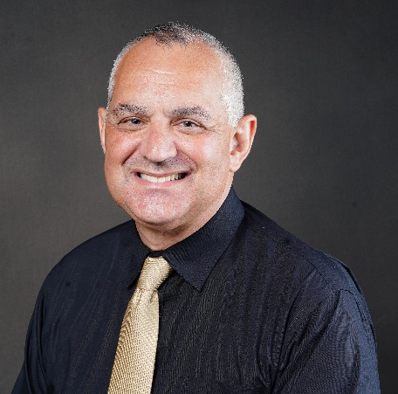  Dr. Neil Knobloch  Purdue University | Neil Knobloch is a Professor of Agricultural Sciences Education at Purdue University. Dr. Knobloch’s scholarship focuses on motivating and engaging K-12, undergraduate, and graduate students in the agricultural sciences to support and advance the STEM career pipeline and system. He teaches courses on research design for social scientists, integrated STEM education, and preparing faculty and graduate students to be inclusive learner-centered teachers. He is a Fellow of the American Association for Agricultural Education.  Neil has been actively engaged in the American Association for Agricultural Education for over 20 years and has been recognized as Distinguished Agricultural Teacher Educator, Distinguished Researcher, 4 Outstanding Article Awards in the Journal of Agricultural Education, and advisor of 4 Outstanding Master’s Thesis Awards. He has served in several leadership roles in AAAE, including President of the North Central Region, Mentor of the National Leadership Academy, Chair of the JAE Editing-Managing Board, Chair of the 2010 AAAE Research Conference, Chair of the Research Committee.  Neil has served in several leadership roles at Purdue University, including the University Senate (6 years), Purdue Agriculture PK-12 Council Chair (11 years), Mentoring@Purdue Co-Director (10 years), and Departmental Graduate Chair (5 years). He is passionate about advancing inclusive excellence and co-developed the National Learner-Centered Teaching and Mentoring Conference in collaboration with the NC-AAAE Conference since 2019. Neil and June have 3 adult children who are all Boilermakers—their sons work for Brock Grain Systems and John Deere and their daughter is a junior in Hospitality and Tourism Management.
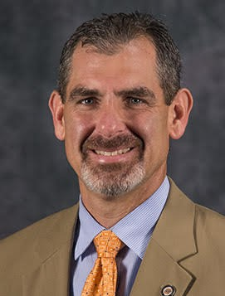  Dr. J. Shane Robinson  Oklahoma State University | Dr. J. Shane Robinson is a Professor in Agricultural Education in the Department of Agricultural Education, Communications and Leadership at Oklahoma State University (OSU). In this position, Robinson teaches courses related to teacher education at the undergraduate level and social science research methods at the graduate level. His research is centered on the scholarship of teaching and learning and the human capital theory regarding the skills and experiences necessary for employability in various sectors of the agricultural industry. In addition, he serves on both graduate and undergraduate committees supporting student engagement and success. Specifically, Robinson has chaired the committees of three AAAE Kahler Dissertation Award winners as well as numerous other doctoral and master’s student committees at OSU. In addition to being a professor, Robinson serves as the Associate Director of the Institute for Teaching and Learning Excellence (ITLE) where he and his team provide professional development and support for increasing the teaching effectiveness of faculty at OSU. Finally, Robinson is a co-director of the Rural Renewal Initiative at OSU where he and his team attempt to catalyze and renew rural communities across Oklahoma and beyond through research, student mobilization, and community development.  Dr. Robinson has served on the AAAE professional improvement, professional development, teacher standards, and research committees. In addition, he has been the Team Leader of the AAAE Strategic Plan for Goal Team 4: Increasing the impact of our scholarship. He also has served as co-chair of two southern region AAAE conferences. Robinson has been a reviewer for the Journal of Agricultural Education and a reviewer and discussant for various AAAE regional and national research paper and poster submissions. Robinson was elected as an AAAE Fellow in 2020.  Prior to his role at OSU, Robinson was an assistant professor in agricultural education for one year at the University of Kentucky. In addition, he received his PhD in agricultural education from the University of Missouri, and he taught high school agricultural education for three years at Sapulpa High School, Sapulpa, OK.

Secretary
Dr. Ryan Anderson  Texas State University | Ryan Anderson is an Assistant Professor of Agricultural Education & Mechanics at Texas State University. In this position, Dr. Anderson teaches courses in AFNR teacher education and agricultural mechanics, conducts research on the teaching and learning of agricultural mechanics in secondary and post-secondary settings. Dr. Anderson is an active grantsman serving as a PI on nine active grants worth approximately $2,200,000. He received the 2022 Texas State University Presidential Award for Excellence in Research and is one of six finalist for the 2023 Texas State University Presidential Award for Excellence in Service.  Anderson has served on the AAAE professional development committee, member services, program improvement committee, AAAE national research chair, AAAE national poster chair, AAAE Ag Mech SIG chair, JAE editing managing board, and the CTER/CTE editing managing board. In addition, Anderson participated in the 2006 OMEGA program and is participating in the 2022-2023 AAAE Leadership Academy. At the state level, Anderson serves at the Superintendent of the San Antonio Livestock Exposition Jr. Ag. Mech Show and as a judge to numerous ag mech shows.  Prior to his role at Texas State, Anderson was a professor at Sauk Valley Community College where he founded their agriculture program. He was an Assistant Professor at Iowa State University where he worked in both agricultural studies and teacher education degree programs. Anderson taught high school AFNR for two years in Illinois before pursuing his PhD at Virginia Tech. Throughout his professional life, Anderson’s commitment to supporting and improving Agricultural Education has expanded and he hopes to extend this commitment as the AAAE Secretary.
Dr. Amber Rice  The University of Arizona | Amber Rice is an Associate Professor of Agricultural Education at The University of Arizona. In this position, Dr. Rice teaches undergraduate and graduate courses in agriculture teacher preparation including teaching methods, curriculum development, total program development, and college teaching. Dr. Rice has been awarded the Bart Cardon Early Teaching Career Award in 2018 and the David E. Cox Faculty Teaching Award in 2022 for the College of Agriculture and Life Sciences at The University of Arizona for her teaching excellence. Her research is focused on teacher knowledge, specifically the content knowledge and pedagogical content knowledge of agriculture teachers and the beliefs, motivations, and influences of this knowledge development. She currently serves as the Curriculum for Agricultural Science Education (CASE) executive committee chair, and holds other department, college, and university service commitments.  Dr. Rice has served as chair of the AAAE Professional Development Committee. Additionally, she participated in the 2018 OMEGA program and is participating in the 2022-2023 AAAE Leadership Academy. In 2022, she was awarded the AAAE Distinguished Teacher Educator Award. At the state level, Dr. Rice serves on the Arizona Agriculture Teacher’s Association Board, co-chairs Arizona Team Agricultural Education, and volunteers extensively for Arizona Association FFA. She was awarded the Post-Secondary Educator of the Year Award in 2019 and the Outstanding Service Award in 2022 for her dedication to teacher education by the Arizona Agriculture Teachers Association.  Prior to her role at The University of Arizona, Dr. Rice was a faculty member at the University of Georgia and a graduate assistant at the University of Missouri. Dr. Rice taught high agriculture for four years at Nelson County High School in Bardstown, KY. Throughout her professional career, Dr. Rice remains committed to serving the professional association through teaching, research, and service initiatives and would welcome the opportunity to serve in a leadership position on the AAAE Board.

Historian
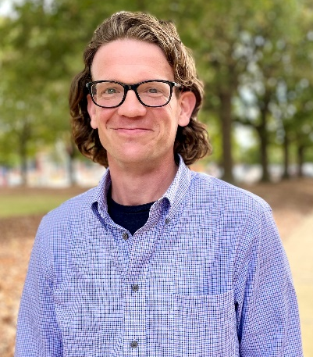  Dr. Jason McKibben  Auburn University | Jason McKibben is an Assistant Professor of Agricultural Education at Auburn University. In this position, Dr. McKibben focuses on graduate programing and the development of graduate students for agricultural education. He currently serves on 50+ active graduate committees including 35 PhD. He teaches courses on data analysis in social science for agriculture, youth program development for agriculture, field experiences in agriculture, agricultural structures, and agricultural power/machinery.  Jason has served as chair for national program improvement committee (2020-21), co-chair/co-host of the online AAAE national meeting (2021), developed and managed the AAAE mini-grant for travel program, member of the JAE editing managing board, national conference planning committee member (2022), Chair of the Blue Ribbon Agricultural Mechanics professional development research meeting, Chair of the Ag Mechanics SIG (2016), Chair of the NC- member services committee (2018), and is currently “chair in waiting” for Southern member services committee. Jason serves as a superintendent of the agricultural technologies and mechanical systems National CDE (natural resources), State superintendent of the ATMS CDE (AL). Jason was honored with an Honorary Alabama State FFA degree in 2022.  Prior to his time at Auburn University, Jason served as an assistant professor at West Virginia University where he led the graduate program in AGEE, taught data analysis for the Davis College of Agriculture, and agricultural mechanics courses. At West Virginia, Jason was ATMS superintendent and served as the scoring superintendent for the state CDE’s. Before West Virginia Jason was a graduate student at Texas A&M. Jason taught high school agriculture in Texas for 8 years.  Jason is eager to help serve this organization in the role of historian. Jason came to agricultural education after studying history and anthropology at Texas A&M where he focused on folklore and maintains a segment of his research focused on the culture and history of agricultural education. He would like to be able to bring his background in archival and historical work to our organization..
Dr. Desiree Rucker-Ross  USDA-NIFA |  | Dr. Desiree Rucker-Ross is Program Specialist with the National Institute of Food and Agriculture. She has actively supported a diverse portfolio of programs across NIFA for over eight years. She has served as lead program specialist for Agriculture and Food Research Initiative (AFRI), Non-AFRI and Capacity programs. In addition, she was selected as primary specialist for two new programs introduced in 2020: Farm of the Future and Regional Innovations for Climate-Smart Agriculture and Forestry.  Dr. Rucker-Ross has a passion for actively engaging youth in agricultural leadership and stakeholder engagement. She mentors young women leaders through her membership with International Leadership Association by coming together once a month discussing how culture matters in youth engagement. As a previous 4-H Agent in Bexar County, Texas, Dr. Rucker-Ross developed a passion for youth engagement in agriculture. She became a member of AAAE to expand her leadership skills for developing the next generation of Agriculture Educators.  She earned her Doctorate in Agricultural Leadership from Texas A&M University where she concentrated on Stakeholder Perception of the Mountain Lion in Texas. She worked closely with ranchers, hunters, and wildlife professionals. She earned a certificate in nonprofit management from the Bush School of Government and Public Service at Texas A&M while completing her doctorate. She earned her MS in Animal Science from Prairie View A&M concentrating on protein identification as fertility markers in the male goat. She earned her BS in biology from the University of Texas at San Antonio.
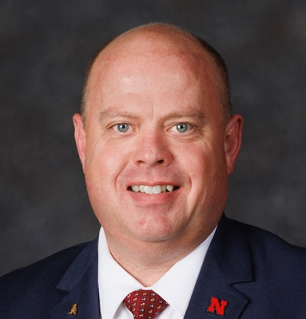  Dr. Troy White  University of Nebraska-Lincoln |  | Troy White is a Lecturer of Agricultural Leadership, Education, & Communications at the University of Nebraska-Lincoln. In this position, Dr. White teaches professional development short-courses across Nebraska to current teachers and undergraduate students, conducts research on teacher professional development, supervises student teachers, and supports current and future AFNR teachers through active participation in a wide range of interdepartmental programs, partnerships with the state Department of Education, and federally funded workshops.  At the national level, Dr. White has served on the National FFA Conduct of Chapter Meetings LDE committee for nine years. At the state level, White served as the SD FFA Conduct of Chapter Meetings LDE superintendent for six years, received the South Dakota FFA Honorary Degree in 2021, and has volunteered extensively for both the South Dakota and Nebraska FFA.  Prior to his role at UNL, White was an Assistant Professor of Agricultural Education at South Dakota State University where he taught pre-service courses in agricultural education and agricultural engineering. White was a graduate research assistant and instructor at the University of Idaho where he worked in Agricultural Systems Management and teacher education. White taught high school AFNR for ten years in Oregon and Idaho.  Throughout his professional life, White has actively engaged in the preservation and documentation of the history of School-based Agricultural Education and the FFA. Preserving and documenting the history of the AAAE naturally aligns with his personal interests and career goals.

AAAE Representative to the National Council for Agricultural Education Board
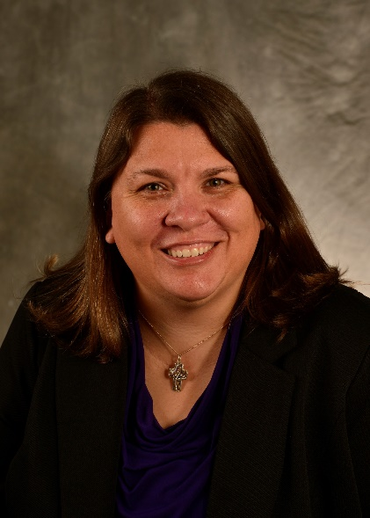  Dr. Candis Carraway  Stephen F. Austin State University | Candis Carraway is currently an Assistant Professor of Agriculture at Stephen F. Austin State University (SFASU). She will be promoted to Associate Professor in September. Dr. Carraway teaches courses in general agriculture, agricultural education, and secondary education. She is the director of the agriculture teacher preparation program at SFASU. She conducts research related to teacher preparation, recruitment and retention. In addition, Candis is passionate about presenting workshops and providing resources to teachers regarding teacher burnout.  Dr. Carraway has served on the AAAE professional development committee and participated in the 2016 OMEGA program. She is currently serving on the SAE For All Advisory Committee and has been heavily involved with Curriculum for Agricultural Science Education (CASE) which are both associated with the National Council for Agricultural Education. At the state level she serves as the Chair of the Texas Teach Ag Committee and has served in this capacity since 2018. Candis serves as the university representative on the Texas FFA Board of Directors and serves as the Chair of the Texas FFA Agriscience Fair. She was recently elected as the Secretary of the Agricultural Consortium of Texas which represents all universities in Texas who teach agriculture. She received her Honorary American FFA Degree in 2012.  Prior to her role at Stephen F. Austin State University, Candis served as an Assistant Professor of Agricultural Education at Washington State University, a graduate teaching assistant at Texas Tech University, and taught secondary agriculture for 16 years. For the last 26 years Dr. Carraway has been committed to serving all facets of agricultural education and hopes to further her service as the AAAE representative for the National Council for Agricultural Education.
Dr. Daniel D. Foster  Penn State University | Daniel Foster is an Associate Professor of Agricultural and Extension Education at Penn State. He provides leadership to the agricultural teacher preparation program at Penn State. His course load includes undergraduate and graduate level teaching methods courses, courses in global agricultural education, courses in parliamentary procedure and courses in other school-based agricultural education teacher education areas as needed. Daniel’s research focus is on developing digitally literate, globally competent agricultural educators who are prepared to help students engage in global food, fiber, and natural resource issues.  Daniel has been a member of AAAE since 2006. During that time, he has helped provide leadership to the Teacher Education Special Interest Group/Caucus, served as the Program Improvement National Committee Chair, served on National Research Committee and in special committee roles around strategic planning implementation and bylaws. Since 2014, he has been an active member of the National Supply and Demand Project Team for AAAE. He is currently the North Central AAAE Secretary.  Daniel has also served other Ag Ed Related Organization (AERO) including the National FFA as the superintendent of the National FFA Parliamentary Procedure LDE and served National Association of Supervisors of Agricultural Education (NASAE) as their parliamentarian.  Prior to his role at Penn State, Daniel was a graduate teaching assistant at The Ohio State University where he worked agricultural teacher education under the guidance of Dr. Susie Whittington. Daniel taught high school agriculture for four years at Willcox High School in Willcox, Arizona.  Daniel is committed to listening, learning, and providing perspective as the AAAAE representative to the National Council for Agricultural Education. He hopes for the opportunity to serve AAAE and school-based agricultural education in positioning agricultural education to thrive in future years.
Chaney Mosley, PhD  Middle Tennessee State University | Chaney Mosley is Assistant Professor of Agricultural Education and Associate Director of the Tennessee STEM Education Center at Middle Tennessee State University (MTSU). In this position, Chaney teaches courses in AFNR teacher education, conducts research on school-based agricultural education (SBAE) with regard to stress and mental health, among other topics, and is actively engaged in external funding and outreach efforts. Since joining MTSU in the fall of 2018, Chaney has served as PI or Co-PI for more than $25 million of externally funded projects; one of these projects resulted in the creation of two Career Kits for the SAE for All program which is managed by the National Council for Agricultural Education and supported by the National Association of Supervisors of Agricultural Education.  As a Lifetime member of AAAE, Chaney has served as a manuscript reviewer for the Journal of Agricultural Education and reviewer for AAAE, and AAAE-SR conference proposals. He was theme editor for The Agricultural Education magazine focused on workforce development and served on the editorial board for Techniques, the monthly magazine published by the Association for Career and Technical Education (ACTE). Chaney currently serves as First Vice President for Alpha Tau Alpha, the National Professional Honorary Agricultural Education Organization, and is President-elect of ACTE. In Tennessee, Chaney has served on the Tennessee FFA Board of Directors for the past five years, the Davidson County Farm Bureau Board of Directors for the past four years, and serves on the Career and Technical Education advisory committee for three different school systems representing agricultural education.  Prior to his role at MTSU, Chaney was CTE Director and high school administrator for Metropolitan Nashville Public Schools, Senior College and Career Readiness Specialist at American Institutes for Research, and the Executive Secretary for Tennessee FFA. He earned his PhD from Virginia Tech; before that, he taught middle and high school agriculture for seven combined years in Tennessee and Georgia. Throughout his career, Chaney has worked to support agricultural education through professional development sessions, coordinating competitions, engaging with related organizations, and other activities. He was recognized as the Outstanding Young Member and the Outstanding Secondary Program by the Georgia Vocational Agriculture Teachers Association, Honorary State FFA Degree recipient from Tennessee, and Honorary American FFA Degree recipient from National FFA. He looks forward to continued SBAE service as the AAAE Representative on the National Council for Agricultural Education.

AAAE Representative to the Agricultural Education Magazine Editorial Board
Barry Croom  University of Georgia | Dr. Barry Croom has more than thirty-five years of experience in agricultural and extension education. His career interest developed as a high school junior when he coached his first dairy judging team for the local junior high school FFA program. Croom began his professional career as a high school agricultural education teacher. While teaching full-time, he earned a Master of Education Degree in Agricultural Education. While a high school teacher, Croom was selected by the National FFA Organization to develop and present in-service workshops to teachers across the United States. His students earned state and national recognition for academic achievement. He was recognized as the Sampson County Schools Teacher of the Year and received the Honorary American FFA Degree from the National FFA Organization.  In 1996, Croom became an Extension associate responsible for the statewide FFA Program at North Carolina State University. After completing his doctoral degree in 1999, he became an assistant professor in the same department. Croom worked through the ranks to become an Alumni Distinguished Undergraduate Professor at North Carolina State University. He has served as an agriculture teacher, teacher educator, extension associate, state education staff member, professor, and department head in agricultural education and agricultural sciences.  Croom has taught leadership, information technology, experiential learning, instructional methodology, educational program planning, and youth development courses. He has conducted more than 30 courses at the graduate and undergraduate levels. Croom maintains a research program focusing on effective teaching, career and technical education policy, and agricultural and extension education diversity. He is the author of three textbooks, 48 peer-reviewed publications, and more than 20 popular publications.  As a member of AAAE, he has served as editor of the Journal of Agricultural Education and theme editor of the Agricultural Education Magazine. He is an AAAE Senior Fellow and has served as AAAE treasurer and historian.  As part of his outreach and engagement efforts, he directed the North Carolina Farm Bureau Institute for Future Agricultural Leaders for several years. Croom led the Oregon Team AgEd Board and served on the Oregon Agriculture in the Classroom Foundation Board and the Oregon Agricultural Education Foundation’s Summer Agriculture Institute Board. He coordinated the Western Oregon Summer Agricultural Institute.  Barry Croom served as Professor and Department Head for Agricultural Education and General Agriculture at Oregon State University before returning to his native South. Part of his responsibilities included training and development for high school teachers. Dr. Croom is now a professor for Agricultural Leadership, Education, and Communication at the University of Georgia. He divides his time between teaching courses on the Athens and Tifton campuses.
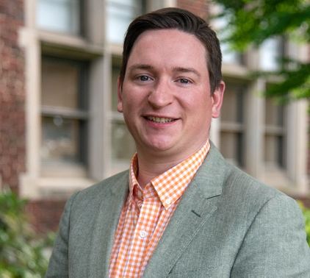  Dr. Jamie Greig  The University of Tennessee, Knoxville | Dr. Jamie Greig is an Assistant Professor of Agriculture Communications at the University of Tennessee, Knoxville. He conducts teaching and research at the intersection of agriculture and communication technology. As a passionate educator, he imparts essential skills for magazine production through his courses, encompassing graphic design, photography, layout, writing, and marketing, while also investigating the impact and adoption of information and communication technology in the agricultural sector.  Before pursuing his Masters and PhD in Communication at the University of Tennessee, Dr. Greig obtained a Bachelor's of Arts in Journalism from the Robert Gordon University in Scotland. This academic foundation, coupled with his hands-on experience as a reporter for the Press and Journal and Evening Express newspapers covering Scotland's North East Coastline, has honed his proficiency in the print media landscape.  Before taking up his current role in the Department of Agricultural Leadership, Education, and Communication, Dr. Greig was a graduate teaching associate in the Department of Journalism. For four years, he was the instructor of record for classes in media writing and multimedia content creation. Dr. Greig's experience in print media and his dedication to agricultural education make him an ideal candidate for a position on the editorial board of the Agricultural Education Magazine.
Jay Solomonson is an Assistant Professor of Agricultural Education at Illinois State University. In this position, Dr. Solomonson teaches courses in agricultural education, agricultural leadership and communications, and agricultural mechanics. His research focus is on agriculture teacher recruitment and retention and the scholarship of teaching and learning. He also serves on several departmental, college, and university committees. Prior to his role at Illinois State, Solomonson served a year on the Illinois Agricultural Education State Staff and 17 years as a high school agriculture teacher, FFA advisor, and CTE Director.

Solomonson has served on the executive boards of the National Alpha Tau Alpha Honorary Agricultural Education Organization, the Illinois Association of Vocational Agriculture Teachers, the Illinois Association FFA, and the Illinois Association for Career and Technical Education. He currently serves as the chairperson of the Illinois Agricultural Education University Council. Solomonson was recently recognized as a national finalist for the Association for Career and Technical Education Teacher Educator of the Year Award.

Dr. Solomonson has 10 published journal articles, 33 referred papers and abstracts, and has written nine articles for The Agricultural Education Magazine. He also served as the theme editor for the November/December 2022 issue of The Agricultural Education Magazine.
Dr. Trent Wells  Southern Arkansas University | Dr. Trent Wells is a currently an Assistant Professor of Agricultural Education at Southern Arkansas University. Wells will be joining the faculty at Murray State University as an Assistant Professor of Agricultural Education effective July 1, 2023.  In his current position, Wells teaches courses in agricultural teacher education and agricultural mechanics. Wells’s service and outreach efforts include coordinating and facilitating agricultural mechanics-focused professional development workshops for in-service teachers, facilitating and coordinating FFA events in Arkansas, and consistently engaging in AAAE activities. Wells’s scholarship revolves primarily around technical agriculture skill development.  Wells currently serves on both the Southern Region-AAAE and National AAAE research committees, regularly reviews JAE manuscripts, and has recently contributed to The Agricultural Education Magazine.  Prior to his role at SAU, Wells was a graduate teaching assistant at Iowa State University where his work was focused primarily on agricultural teacher education. Wells taught Agricultural Education courses for three years at Fayette County High School in Fayette, Alabama.

AAAE Representative to the FFA Alumni Council and Supporters Board
Dr. Wendy Warner  NC State University | Dr. Wendy Warner is an associate professor in the Department of Agricultural and Human Sciences at NC State University. Wendy teaches undergraduate and graduate courses both on-campus and via distance in the areas of agriculture teacher preparation, educational technology, and youth program management. Her research interests focus on technology integration, the influence of performance assessments on the student teaching experience, and the scholarship of teaching and learning.  Wendy has been a member of AAAE since 2003 and is currently the chair of the Program Improvement Committee for the Southern Region. She has served as the secretary for AAAE (2015 – 2017) and Southern Region (2019-2020). Also, she has served as the chair for the Program Improvement Committee at both the national (2012-2013) and regional level (2011-2013). Wendy has been involved with the National FFA Organization for more than 20 years as a former member and middle school and high school FFA advisor. She is a member of the North Carolina FFA Board of Directors and the superintendent of the NC Agricultural Education CDE.

AAAE Representative to the National FFA Foundation Board of Trustees
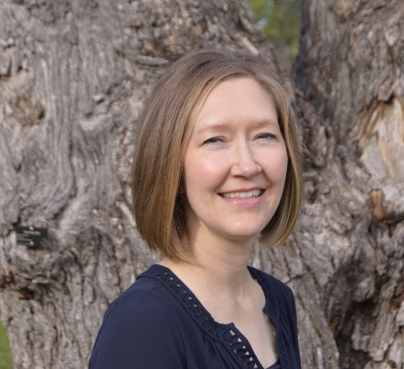  Dr. Ann M. De Lay  California Polytechnic State University in San Luis Obispo |  | Dr. Ann M. De Lay is a Professor of Agricultural Education at California Polytechnic State University in San Luis Obispo.  There, she teaches teaching methods courses, supervises teacher candidates, serves as coordinator for the Master of Agricultural Education program, co-advises the local MANRRS chapter – Latinos in Agriculture, and produces professional development programming for California Agriculture Teachers.  Prior to her current role, Ann earned her Bachelor of Science in Agricultural Education from California State University, Fresno and taught in the agricultural education program at Central High School in Fresno, one of the largest programs in the nation. During that time, she also completed a Master of Science in Agriculture at Cal Poly. Following her secondary teaching experience, Ann completed a PhD in Agricultural Education at the University of Florida.  Her research interests primarily surround (1) the recruitment, professional growth and retention of quality agriculture teachers, (2) the experiences of first-generation college students, and (3) the perspectives of underserved and underrepresented populations in agricultural education and colleges of agriculture. Ann was part of LEAD21 Class 15 and currently serves as the LEAD21 Alumni Board chair.
Dr. Jon Simonsen  University of Missouri | Jon Simonsen is an Associate Professor in Agricultural Education and Leadership at the University of Missouri. In this position, he teaches courses in teacher education and leadership, conducts research in leadership education, and serves as the program chair within the Division of Applied Social Sciences.  Simonsen has served on the AAAE program improvement committee, JAE editing managing board, and chair of the host committee for the 2016 AAAE and 2022 NC-AAAE meetings. He is currently serving on the National FFA Foundation Board of Trustees with his term ending in December. At the state level, Simonsen serves on the Joint State Staff Committee (oversees Agricultural Education in the state of Missouri), received the National FFA Honorary Degree in 2015, and holds State Honorary Degrees from Missouri and Nebraska.  Prior to his role at Mizzou, Simonsen was a graduate teaching assistant at The Ohio State University where he worked in both leadership education and teacher education. Simonsen taught high school agriculture for 10 years in Nebraska before moving to the university level. Throughout his professional life, Simonsen’s service to supporting and improving the FFA Organization has expanded and he hopes to continue that commitment.

AAAE Representative to the National FFA Board of Directors
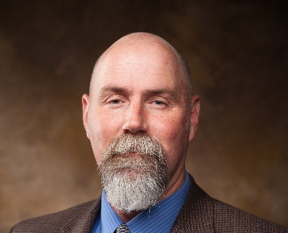  Dr. Don W. Edgar  New Mexico State University | Don W. Edgar is a Professor of Agriculture Education in the Agricultural and Extension Education Department at New Mexico State University. Dr. Edgar leads the teacher education preparation program and teaches courses related to teaching methods and curriculum design at the undergraduate level as well as research methods and statistical analysis at the graduate level. His research has focused on analyzing instructional strategies and curriculum design towards student knowledge acquisition and engagement.  Dr. Edgar has served on the numerous AAAE committees throughout the years at the regional and national level. He was the Southern Region AAAE president and has also been the research committee chair for the region. Presently, he is the Journal of Agricultural Education Editor where he has served for the past two years and is tasked with changing to platform hosting the review and publication processes involved with our journal. Don was in the initial Omega program sponsored by AAAE and the inaugural AAAE Leadership Academy.  Prior to his role at New Mexico State University, Don was at the University of Georgia, University of Arkansas and began his role in post-secondary education at South Dakota State University. Don taught high school agricultural sciences for 14 years in Texas. His understanding and knowledge of agricultural education and FFA would be a valuable asset for this postion.
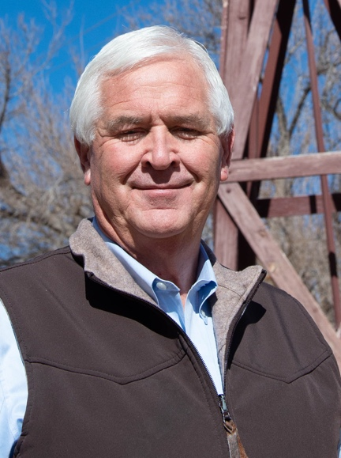  Dr. Steve Fraze  New Mexico State University | Dr. Steve Fraze is currently Professor and Department Head, New Mexico State Univ., Las Cruces, N.M. and has served in that role since January 2020. Prior to coming to NMSU, Dr. Fraze was Professor and Department Chair at Texas Tech University, Lubbock, TX serving in that role from 2008-2020. During this time, he served as Interim Dean, College of Agricultural Sciences and Natural Resources from August 2016 until April 2018. His total tenure at Texas Tech started in the fall of 1988 as an Assistant Professor. His focus in teaching and research has always been in the development of agricultural educators at the both the secondary and collegiate level.  After receiving his Ph.D. at Texas A&M and prior to his time at Texas Tech and New Mexico State, Fraze held positions at Texas A&M (Assistant Professor/Curriculum Specialist) and Cal Poly State University, San Luis Obispo (Visiting Lecturer, Agricultural Education). Before attending graduate school at Texas A&M, Fraze held positions of Vocational Agriculture Teacher at New Home, Texas and Olton, Texas.  Dr. Fraze has been involved on a national level with both AAEA and the National FFA throughout his career. He has served AAEA as President (2015-2016), Western Region officer team (secretary, President-Elect, & President 2007-2012), and the Executive Board of Directors (2010-2012 & 2014-2017). He receive recognition as a “Fellow” of AAEA in 2014. Fraze represented AAAE as a Consultant to National FFA Board of Directors (2004-2006) and on the National FFA Foundation Board of Directors (2005-2006). Fraze served on the National FFA Livestock Career Development Event Committee from 1990 – 2016 as Assistant Superintendent, Superintendent, and Associate Superintendent.
Dr. Kristin Stair  Louisiana State University | Dr. Kristin Stair is a Professor of Agricultural Education in the Department of Agricultural and Extension Education and Evaluation at Louisiana State University. Her primary role within the department is focused on teacher education coursework including methods of teaching, working with diverse learners, and instructional design in agricultural education. She also serves as the coordinator of the student teaching program and the advisor for the Collegiate FFA at LSU alumni chapter. At LSU she has also had the opportunity to serve on the LSU Faculty Senate, the Agriculture Faculty Council, and currently serves on the Louisiana Agricultural Education Commission and the Louisiana Foundation Board.  She has served AAAE as the National Secretary (2017-2019) and is currently serving at the President-Elect of the Southern Region. She has been a participant of the AAAE Leadership Academy and has served as a member and Chair of the Professional Development Committee at the national level as well as member and Chair for the Western and Southern regions. Her research focuses on the exploration of various teacher concerns within agricultural education and several of her research studies have served as the basis for professional development workshops for teachers at the state and national level. She has been very involved in FFA contests and events throughout her career including currently serving as the Superintendent of the Louisiana Geaux Teach Ag LDE and the Louisiana Agriscience Fair. At the National level, she has served on the National Agriscience Fair Planning Committee (2011-2013) and as an invited workshop presenter for workshops related to working with diverse learners in agricultural education.  Prior to coming to LSU, she taught high school agriculture in North Carolina, was a Lecturer at North Carolina State University, and a faculty member at New Mexico State University.

AAAE Representative to the National FFA Board of Directors (Alternate)
Adam Marx is an Associate Professor of Agricultural Education at North Dakota State University (NDSU). Dr. Marx teaches undergraduate and graduate courses in agricultural education teaching methods, leading youth organizations, Extension education, and program development and evaluation. Adam joined NDSU in 2014 as the only faculty leading Ag Ed programming. Since then through collaborations and partnerships the program has grown to two faculty focused on Ag & Extension Education.

Marx has served AAAE in various capacities the pat nine years. He served on the Member Services committee in the North Central region and National level serving as chair of both. In 2021 he chaired the North Central region Research committee as well. During the most recent AAAE Strategic planning process and implementation, Adam served as a co-lead for one of the key strategies teams. In 2018, he led the host committee for the fall North Central Regional conference held in Fargo. In addition, Marx participated in the 2018 OMEGA program and is participating in the 2022-2023 AAAE Leadership Academy. At the state level, Adam sits on the North Dakota FFA Foundation Board of Directors and the North Dakota Team Ag Ed STAR committee. Adam feels fortunate to have been selected to receive an Honorary State FFA Degree in 2019 and the Honorary American FFA Degree in 2021 from North Dakota FFA.

Prior to NDSU, Marx was a graduate assistant at the University of Missouri. He taught high school agriculture in Ohio at Cory-Rawson Schools and briefly worked in agricultural lending just prior to attending Mizzou. He earned his BS and MS in Agricultural Education at The Ohio State University. Adam appreciates the role the FFA has in the scope of Agricultural Education and hopes that he can be part of the ever-evolving landscape FFA engages youth in through potentially serving in this capacity.

AAAE Representative to the National FFA for Adult Consultant for National Officer Selection
Dr. William Norris  New Mexico State University  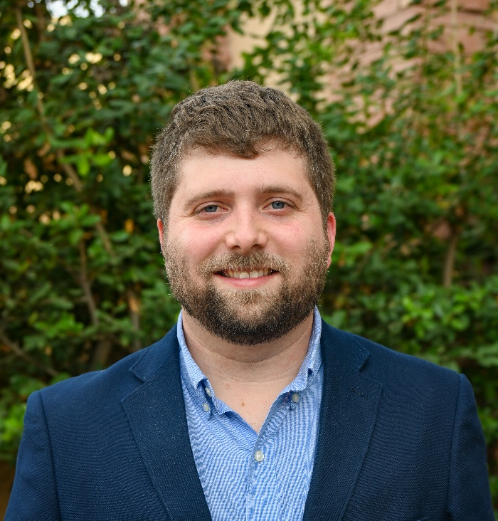 | Dr. William Norris is an Assistant Professor in the Department of Agricultural and Extension Education at New Mexico State University. He graduated with his Associate in Science (A.S) degree from Central Alabama Community College (CACC) and his Bachelor of Science (B.S.) degree in Agriscience Education from Auburn University in 2016. He received his M.Ed. in Agriscience Education in 2017, his Ed.S. degree in Adult Education in 2018, and a graduate certificate in Educational Leadership in 2021 all from Auburn University. In addition, he received his Ph.D. in Agricultural and Extension Education from Mississippi State University in 2021.  Dr. Norris’ research interests focus on teacher retention, STEM integration into SBAE, employability skill acquisition, and the professional development needs of agricultural educators.  Dr. Norris taught secondary agricultural education at Wetumpka High School in Wetumpka, AL from 2018-2022. There he advised the local FFA chapter, operated a school farm, severed on numerous committees for the Alabama FFA Association, and helped develop the Course of Study (COS) for agricultural education in Alabama. In 2019, Norris joined the SAE Awards Committee for the National FFA Organization which guides the judging and review process for SAE-based awards. In 2021, Norris received the “Outstanding New Teacher” award from the Alabama FFA Association.  As a FFA member, Dr. Norris served on the national officer nominating committee to assist in the selection of the 2014-2015 national FFA officer team. It is Dr. Norris’ desire to represent AAAE as an adult consultant for this committee and assist in guiding the national FFA officer selection process.

