**Southern Region Conference**

**of the**



**2016 PROGRAM**

**Held in conjunction with the meeting of the**

**SOUTHERN ASSOCIATION OF AGRICULTURAL SCIENTISTS (SAAS)**



**February 5 – February 9, 2016 – San Antonio, TX**

**Hyatt Regency San Antonio**

**Hosted by**

**Department of Agricultural and**

**Extension Education and Evaluation**

**Louisiana State University**

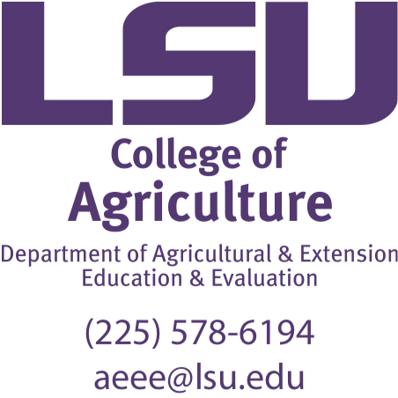

**Southern Association of Agricultural Scientists (SAAS)**

**Agricultural Education Division Officers**

President and Conference Chair: JC Bunch

Conference Co-Chairs: Joey Blackburn, Kristin Stair

Louisiana State University

Past President: David Jones, North Carolina State University

**American Association for Agricultural Education (AAAE)**

**Southern Region Officers**

President: Don Edgar, University of Arkansas

Vice-President: John Rayfield, Texas A&M University

Secretary: Andrew Thoron, University of Florida

**Manuscript Reviewers for 2016 AAAE Southern Region Research Conference**

Alexa Lamm

Alyx Shultz

Amy Harder

Andrew Thoron

Barbara Kirby

Brian Myers

Brian Parr

Carrie Stephens

Catherine Shoulders

Chris Estepp

Christopher Stripling

David Agnew

David Jones

Dennis Duncan

Don Edgar

Don Johnson

Donna Graham

Donna Westfall-Rudd

Doug LaVergne

Ed Osborne

Elizabeth Wilson

Eric Kaufman

Eric Rubenstein

Frank Flanders

Gaea Hock

Gary Moore

George Wardlow

Grady Roberts

Hannah Carter

Holli Leggette

Jack Elliot

James Bunch

James Christianson

James Dyer

James Hynes

James Lindner

Jay Jayaratne

Jennifer Williams

Jeremy Robinson

Jim Flowers

Joey Blackburn

John Hall

John Rayfield

John Ricketts

Jon Ramsey

Joy Rumble

Julie Harlin

Katie Stofer

Kay Kelsey

Kim Dooley

Kirby Barrick

Kirk Edney

Kirk Swortzel

Kristin Stair

Laura Lemons

Laura Warner

Leslie Edgar

Mark Kistler

Michael Edwards

Michael Newman

Nick Fuhman

Nicole Stedman

Quisto Settle

Rene Miller

Robert Strong

Robert Williams

Sheyenne Krysher

Stacy Vincent

Summer Odom

Susan Seal

Tiffany Drape

Tobin Redwine

Todd Brashears

Tracy Rutherford

Travis Park

Wash Jones

Wendy Warner

William Weeks

**Saturday, February 6 2016**

**3:00 – 6:00 p.m. Registration Regency Ballroom Foyer**

**Sunday, February 7, 2015**

**7:00 – 8:00 a.m. Graduate Student Breakfast Garden Terrace**

Facilitator: PD Committee *(Pre-registered graduate students)*

**7:00 – 10:00 a.m. Registration Regency Ballroom Foyer**

**8:15 – 8:45 a.m. Vespers Regency West 4, 5, 6**

Facilitator: Dr. Shane Robinson

**9:00 – 9:30 a.m. Agricultural Education Opening Session Regency West 4, 5, 6**

**9:45 – 11:45 a.m. Concurrent Research Session I**

**Session A: Pedagogy and Learning Rio Grande Ballroom - West** Chair and Facilitator: Tre Easterly

Discussant: Dr. Don Johnson

An Exploratory Examination of the Kolb Experiential Educator Role Profile

*Marshall A. Baker, Jason P. Twenter*

Student Teaching Changed Me: A Look at Kolb’s Learning Style Inventory Scores Before and After the Student Teaching Experience

*Kasee L. Smith, John Rayfield*

A Comparison of Experiential Learning Techniques & Direct Instruction on Student Knowledge of Agriculture

*Timothy Bradford Jr., Dr. Gaea Hock, Dr. William Kingery*

Undergraduate Student Thoughts on Using the Science of Genetic Modification as a Solution to Citrus Greening

*Dr. Joy N. Rumble, Taylor K. Ruth, Courtney T. Owens, Dr. Alexa J. Lamm, Melissa R. Taylor, Dr. Jason D. Ellis*

**Session B: Agricultural Communications and Issues Regency West 4, 5, 6**

Chair and Facilitator: Carli Calico

Discussant: Dr. Donna Graham

Communicating about Contentious Issues: Florida Extension Agents’ Role

*Leal, A., Rumble, J. N., Lamm, A. J., & Gay, K. D.*

Undergraduate Students’ Knowledge of International Agricultural Issues by Academic Standing

*Sarahi Morales, Todd Brashears*

Teaching with Animals: The Role of Animal Ambassadors in Improving Presenter Communication Skills

*Dr. Nicholas E. Fuhrman, Dr. Eric D. Rubenstein*

Identifying the Needs of Opinion Leaders to Encourage Widespread Adoption of Water Conservation and Protection

*Melissa R. Taylor, Dr. Alexa Lamm*

**Session C: Undergraduate Student Experiences Rio Grande Ballroom Center**

Chair and Facilitator: Sarah LaRose

Discussant: Dr. Kirk Swortzel

Experiences of Hispanic Students Enrolled in a College of Agriculture

*Isabel Whitehead, Christopher M. Estepp*

Personality and Goal Orientation of Undergraduate Agricultural Leadership Students: An Empirical Analysis

*Dr. Kevan W. Lamm, Emana Sheikh, Dr. Hannah S. Carter, Dr. Alexa J. Lamm*

Relationship Between Academic Engagement, Achievement, and Student Satisfaction Among Seniors in a Land Grant College of Agriculture

*Donald M. Johnson, Catherine W. Shoulders, Leslie D. Edgar, Donna L. Graham, & K. Jill Rucker*

Perceptions of Agricultural Careers for African American Students Through the Lens of the Holistic Development Theory

*Marshall A. Baker, Cassie M. Graham, Richie Roberts, Diane Montgomery*

**12:00 – 1:30 p.m. Luncheon Garden Terrace**

*Introduction of graduate students and new faculty*

**1:30 – 2:45 p.m. Committee Meetings**

Membership Services **Medina**

*Christopher Estepp, Chair*

Program Improvement **Bowie C**

*Gaea Hock, Chair*

Professional Development **Guadalupe**

*Chris Stripling, Chair*

Research **Pecan**

*Laura Lemons, Chair*

**2:45 – 3:45 p.m. SR-AAAE Business Meeting Session I Rio Grande Ballroom Center**

Don Edgar, SR-AAAE President

**3:45 SIG Meetings Announcement at AgEd Opening Session**

**4:00 – 4:15 p.m. SAAS General Business Meeting TBA**

**4:15 – 5:30 p.m. SAAS Concurrent Sessions TBA**

**Monday, February 8, 2015**

**7:00 – 10:00 a.m. Registration Regency Ballroom Foyer**

**7:00 – 8:30 a.m. Continental Breakfast & Regency Ballroom Center  
Innovative Poster Session**

**Innovative Posters**

A Flicker of Light: Using Mobile Experiences to Educate Consumers about Energy Efficiency

*Sable Sellick, Janviere Umuhoza, Catherine Shoulders*

University of Arkansas

A Picture’s Worth a Thousand Words: Using Images to Stimulate Non-linguistic Reflection in College Agriculture Courses

*Carley Calico and Catherine W. Shoulders*

Mississippi State University and University of Arkansas

An Authentic Approach to Preservice Teacher SAE Instruction

*Dr. Eric D. Rubenstein, Jillian A. Gordon, & Amanda C. Miller*

University of Georgia

Attracting the Next Generation of School Based Agricultural Education Instructors: An Approach to Recruitment

*Jon Ramsey, Cassie Graham, Hanna Holsapple, Marshall Baker*

Oklahoma State University

Bringing Data to Life through Experiential Learning

*Michelle Santiago, Brian Parr*

Murray State University

Discovering What Lies Beneath: Utilizing Ultrasonic Testing for the Evaluation of Welds in Secondary Schools

*Preston Byrd, Stacy Vincent, & Joan Mazur*

Clemson University & University of Kentucky

EDTHENA – Creating a Community of Reflective Teachers

*Krysti L. Kelley, Hanna Holsapple, Marshall A. Baker*

Oklahoma State University

Engaging participation in the instant communication era

*Sarahi Morales, Carla Millares, Todd Brashears, Baleshka Brenes*

Texas Tech University

Establishing a Crowdfunding Sustainability Project for Resource-Depleted Secondary Agricultural Education Programs

*Ms. Morgan L. Schafbuch, Dr. Stacy K. Vincent, & Dr. Joan Mazur*

University of Kentucky

**Innovative Posters (Continued)**

Graduate Student Entrepreneurship: Answering the Professional Development Needs of Secondary Agriculture Teachers

*Preston Byrd & Ryan Anderson*

Clemson University & Iowa State University

Localizing the Local Food Movement in School-Based Agricultural Education Curriculum

*Sarah E. LaRose, Andrew C. Thoron*

University of Florida

Outback Wildcat: Teaching Agricultural Education in the Land Down Under

*Courtney Crume, Kendall M. Wright, Stacy Vincent, & Rebekah Epps*

University of Kentucky

Owl Pellets – Regurgitating Practical Tips for Agriculture Teachers

*Marshall Baker, Kate Shoulders, Brian E. Myers*

Oklahoma State University

Pedagogical Content Knowledge Development in an Agriscience for Teachers Course

*Amanda C. Miller and Amber H. Rice*

University of Georgia

Promoting College and Career Opportunities in Agriscience: The Tennessee State University College and Research Showcase

*John Hall*

Tennessee State University

Using the Bennett Mechanical Comprehension Test in the Agricultural Mechanic’s Lab

*J. Chris Haynes Ph.D., Steven "Boot" Chumbley Ph.D., Mark Russell, Ph.D., Mark Hainline*

University of Wyoming, Texas A&M University-Kingsville, University of Arkansas, Texas Tech University

Using Weeklong Educational Excursions to Promote International Experiences

*Madelyne Easley, Shelli E. Danjean, J.C. Bunch, Joey Blackburn*

**8:45 – 10:45 a.m. Concurrent Research Session II**

**Session D: Agricultural Leadership Guadalupe**

Chair and Facilitator: TJ Bradford

Discussant: Dr. Ed Osborne

Perceptions of Agricultural Leadership Academic Programs at 1862 Land-Grant Institutions

*Jackson Alexander, Dr. K. Jill Rucker, Dr. Donna L. Graham*

A Theory Based Model of Interpersonal Leadership for Use in Agricultural Leadership Education

*Dr. Kevan W. Lamm, Dr. Hannah S. Carter, Dr. Alexa J. Lamm*

Acculturation and Leadership Styles among Latino or Hispanic Faculty and Staff at [State University

*Baleshka Brenes, Amy Boren, Todd Brashears*

Using Mentor Insights to Enhance Leadership Development Programs

*Dr. Kevan W. Lamm, Dr. Alexa J. Lamm, Dr. L. Rochelle Sapp*

**Session E: School-Based Agricultural Education Programs Rio Grande Ballroom West**

Chair and Facilitator: Jackie Hill

Discussant: Dr. Shane Robinson

Exploring the Motivations of Competitors in the FFA Meats Evaluation Career Development Event

*Kevin Curry Jr, Dr. Wendy Warner, Dr. Travis Park*

Analyzing [State] FFA as a Brand Using Instagram

*Brooke Prather, Lindy Froebel, Dr. Tracy Rutherford*

National FFA’s Brand through the Eyes of Its Members: A Content Analysis

*Jackie Hill, Victor Salazar, Dr. Tracy Rutherford*

Description of Millennial and Non-millennial Agriculture Teachers’ Current and Ideal Emphasis on the Three Components of the Agricultural Education Program

*Dr. Catherine W. Shoulders, Hannah Toland*

**Session F: Teaching and Learning in Higher Education Rio Grande Ballroom Center**

Chair and Facilitator: Dr. Boot Chumbley

Discussant: Dr. Kirby Barrick

Variability versus Continuity: Student Teachers’ Perceptions of Two University Supervision Formats

*Dr. Catherine W. Shoulders, Dr. Don E. Edgar, Andrew Bolton*

Lessons Learned: Describing the Preservice Preparation Experiences of Early-Career Award-Winning Agricultural Educators

*Lockie R. Breeding, John Rayfield;, Kasee L. Smith*

Early-Career Migration of Agriculture and Human Environmental Sciences B.S. Graduates: Evidence from One Land Grant University

*Donald M. Johnson, Catherine W. Shoulders, & Leslie D. Edgar*

A Comparison of the Perceptions of Agricultural Education Professors with Undergraduate and Graduate Students Regarding the Importance of Student-to-Student Interaction in Distance Education Classes

*Gary Moore, Wendy Warner, Jane Bachelor, David Jones*

**11:00 – 12:00 p.m. SR-AAAE Business Meeting Session II Rio Grande Ballroom West**

Don Edgar, SR-AAAE President

**12:00 – 1:30 p.m. Luncheon Garden Terrace**

*Distinguished Lecture*

**1:45 p.m. Professional Development Bowie A, B**

*Best Practices in Online Teaching and Learning*

**4:30 – 6:00 p.m. LSU Host State Social TBA**

Dinner on your own.

**Tuesday, February 9, 2015**

**7:00 – 8:30 a.m. Continental Breakfast & Regency Ballroom Center  
Research Poster Session**

**Research Posters**

A Qualitative Study Investigating Students’ Perceptions of Experiential Learning within an Agriculture Curriculum

*Timothy Bradford Jr., Alayna Naro, Gaea Hock*

Mississippi State University

An Evaluation of a Youth Camp Program's Impact on Parents' Perceptions of Sustainability and Family Engagement

*Emily P. Cabrera, Jessica A. Holt*

University of Georgia

An Examination of a Graduate Learning Community in a College of Agriculture

*Michael Burbank, Summer Odom, & David Reed*

Texas A&M University

Analyzing the Needs of High School Agricultural Education Teachers towards Classroom Diversity & Inclusion

*Douglas D. LaVergne and Hari K. Vommi*

Texas A&M University - Commerce

Beginning Agricultural Education Teachers' Perceptions of their Preservice Teacher Education Program

*Marshall Swafford, J C Bunch*

Eastern New Mexico University, Louisiana State University

Does Selection of the Animal Systems Pathway Influence the Type of SAE Students Choose? A Multi-State Analysis

*Courtney Overstreet, John Rayfield, Roger Hanagriff*

Texas A&M University

Evaluating the impact of a required agricultural mechanics unit modified

*James Thackston, Preston Byrd*

Clemson University

Extension: Building Common Ground Between Leaders of Agriculture and Natural Resources and Public Needs

*Brie Bird, Dr. Alexa J. Lamm*

University of Florida

How Are You Going to Keep Them on the Farm? Identifying which College Majors Return the Most Graduates to Rural Areas

*Kristina Bautista, Donald M. Johnson, Catherine W. Shoulders, and Leslie D. Edgar*

University of Arkansas

**Research Posters (Continued)**

Identifying challenges of Early Career Agents in [State] Cooperative Extension

*Donna Westfall-Rudd, Karen Vines, Adam Cletzer, Neil Vines, Joseph Hunnings, Mark Sumner, Mike Lambur*

Virginia Tech

Identifying Themes to Guide Curriculum Development for the Poultry and Egg Education Project (PEEP)

*John C. Ricketts, Sandria Godwin, Morgan Beaty, Alison Leathers, Edgar Chambers IV, Sheryl Cates*

Tennessee State University, Kansas State University, Research Triangle International

Mechanical Aptitude of Post-Secondary Agricultural Education Majors

*J. Chris Haynes, Steven Boot Chumbley & Mark Hainline*

University of Wyoming, Texas A&M University Kingsville & Texas Tech University

Middle School Agricultural Education Experiences Related to High School Agricultural Education Enrollment in Georgia

*David L. Chapman, Jr., R. Kirby Barrick, Andrew C. Thoron*

University of Florida

Perceptions of Home Community: Do Rural and Metropolitan Students Differ?

*Fawn Kurtzo, Donald M. Johnson, Leslie D. Edgar, and Catherine W. Shoulders*

University of Arkansas

School – Based Agricultural Entrepreneurship Education Programs for Rural Youth: A Synthesis of Current Literature

*Seth Heinert, Dr. T. Grady Roberts*

University of Florida

School Board Members’ and Administrators’ Perceptions of the CASE Curriculum

*Mark Hainline, Jonathan Ulmer, & Candis Carraway*

Texas Tech University & Washington State University

Survey of 1862 Land-Grant University Agricultural Leadership Academic Programs

*Jackson Alexander, K. Jill Rucker, and Donna L. Graham*

University of Arkansas

Which Way Did They Go? Determining College Choice of Louisiana School-Based Agricultural Education Students

*John D. Whittington, Shelli E. Danjean, J. Joey Blackburn*

Louisiana State University

**9:00 – 11:00 a.m. Concurrent Research Session III**

**Session G: School-Based Agricultural Education Teachers Rio Grande Ballroom Center**

Chair and Facilitator: Amanda Miller

Discussant: Dr. Brian Myers

Assessing the relationship of teacher self-efficacy, job satisfaction, and perception of work-life balance of Louisiana agriculture teachers

*J. Joey Blackburn, J. C. Bunch, J. Chris Haynes*

Teachers' Beliefs about the Purpose of Agricultural Education and its Influence on their Pedagogical Content Knowledge

*Amber H. Rice, Tracy Kitchel*

Using Epistemological Positions and Orientations to Instruction to Explore School-Based, Agricultural Educators Perceptual Identities: A Q-Sort Study

*Richie Roberts, Dr. Diane Montgomery*

The Black Swans of Agricultural Education: An Empirical Account of the Unique Lived Experiences that Structure Urban Agricultural Educators Meaning in Work

*Richie Roberts, Dr. Jon W. Ramsey*

**Session H: School-Based Agricultural Education Students Live Oak**

Chair and Facilitator: Hanna Holsapple

Discussant: Dr. Jim Flowers

Connecting Problem-Solving Style to Peer Evaluations of Fellow Team Members’ Performance in Secondary Cooperative Learning Projects

*Sarah Bush, Dr. Curtis Friedel, Lindsay Hoerbert, Thomas Broyles*

Effects of the Order of Abstraction and Type of Reflection on Content Knowledge when Teaching Experientially in a High School Classroom

*Catherine A. DiBenedetto, Jessica M. Blythe, Brian E. Myers*

The Effect of Pedagogy on Students' Long-term Retention of Knowledge

*Marshall A. Baker, J. Shane Robinson*

What’s the Problem? Investigating Factors that Influence the Hypothesis Generation Ability of School-Based Agricultural Education Students when Troubleshooting

*J. Joey Blackburn, J. Shane Robinson*

**Session I: Extension Education and Programming Rio Grande Ballroom West**

Chair and Facilitator: Krysti Kelley

Discussant: Dr. Matt Baker

Exploring the Differences in Water Conservation Behaviors among High Water Users in Three Regions of Florida: Hints for Extension Educators

*Pei-wen Huang, Dr. Alexa J. Lamm, Dr. Michael D. Dukes*

Cognitive Dissonance: A Theoretical Perspective to Explain Intentions to Conserve Water

*Anil Kumar Chaudhary, Dr. Alexa J. Lamm*

Discerning Gaps between Public and Decision Maker Views of Agricultural Water Use to Inform Practice

*Dr. Alexa J. Lamm, Melissa R. Taylor, Kevan W. Lamm*

Using Critical Thinking Styles to Inform Landscape Water Conservation Extension Programs

*Mr. Courtney T. Owens, Dr. Alexa J. Lamm*

**11:00 – 11:30 a.m. BREAK** (no refreshments)

**11:30 – 1:30 p.m. Awards Luncheon Regency West 4, 5, 6**

**Special Guest:** TBA

**SR-AAAE Conference Adjourns after Lunch**

**Hotel/Conference Space Layout**

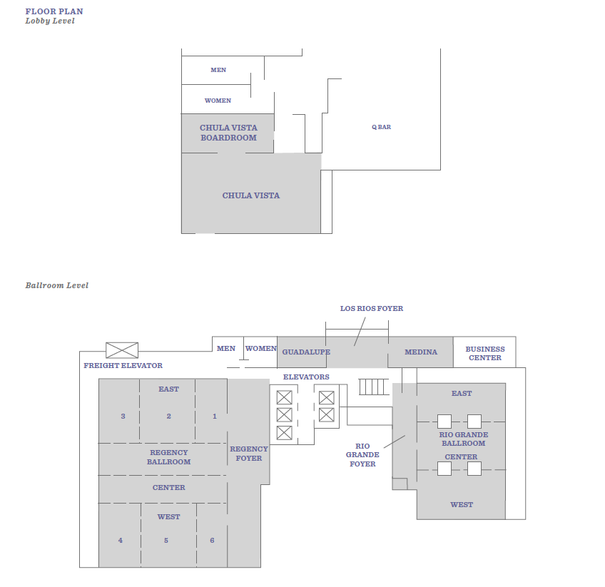

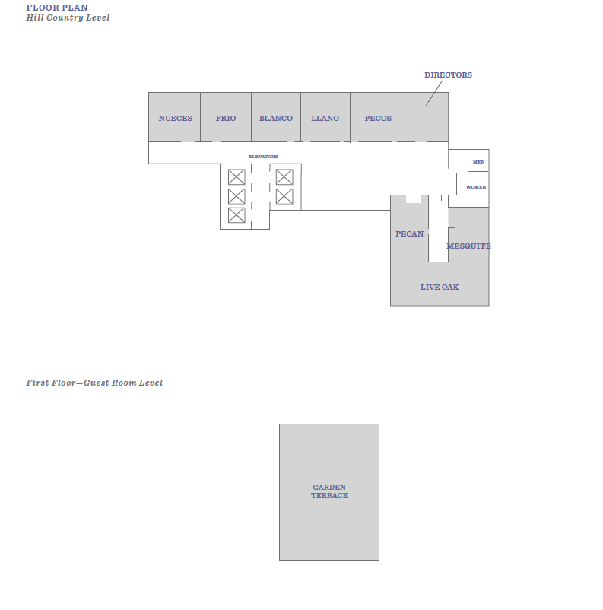

**Future Conference Locations and Dates**

2017 – Mobile, AL (Feb. 4 – 7, 2017)

2018 – Jacksonville, FL (Feb. 3 – 6, 2018)